1. Access to Profile Page Without Logging In:
Issue: Users can access the profile page without being logged in, allowing them to view and update the default name and email.
Recommendation: Implement access control: Check the user's login status before allowing access to the profile page. Redirect to the login page or display a prompt if the user is not logged in.

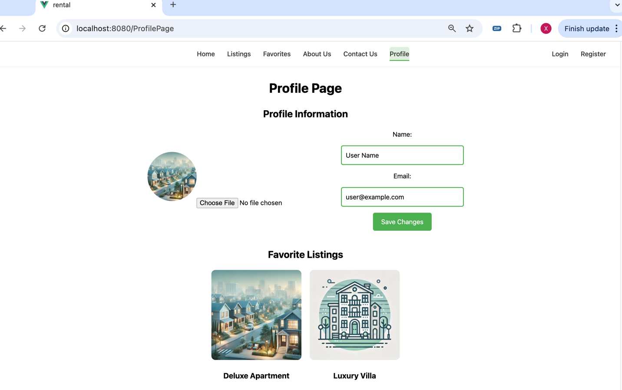

2. File Upload Occurs Immediately Without Confirmation (Profile Picture):
Issue: When users select a file, it is uploaded immediately without any confirmation step.
Recommendation: Add a confirmation step: Display a preview of the selected file and provide “Save” or “Confirm” buttons. Proceed with the upload only after the user confirms.
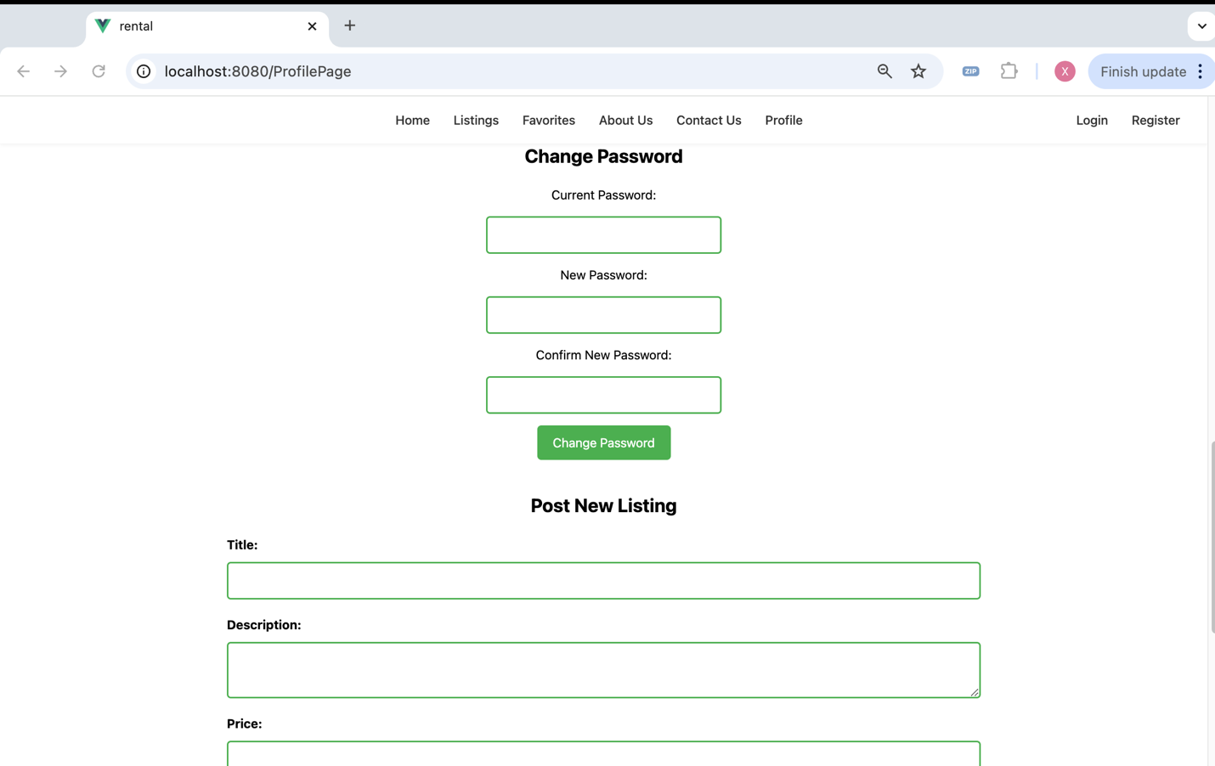

3. Ability to Change Password Without Logging In:
Issue: It’s unusual that users can change their password without being logged in.
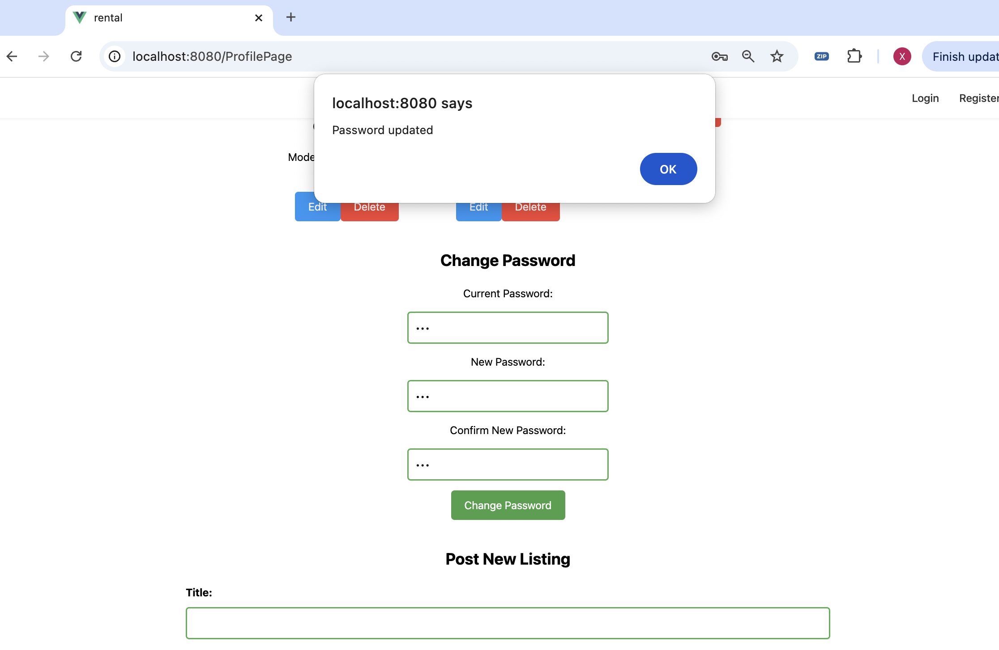

4. Ability to Post Without Logging In:
Issue: It seems strange that posting is allowed without user authentication.

5. “About Us” and “Contact Us” Pages Are Empty:
Issue: These pages might need content retrieval from the backend.

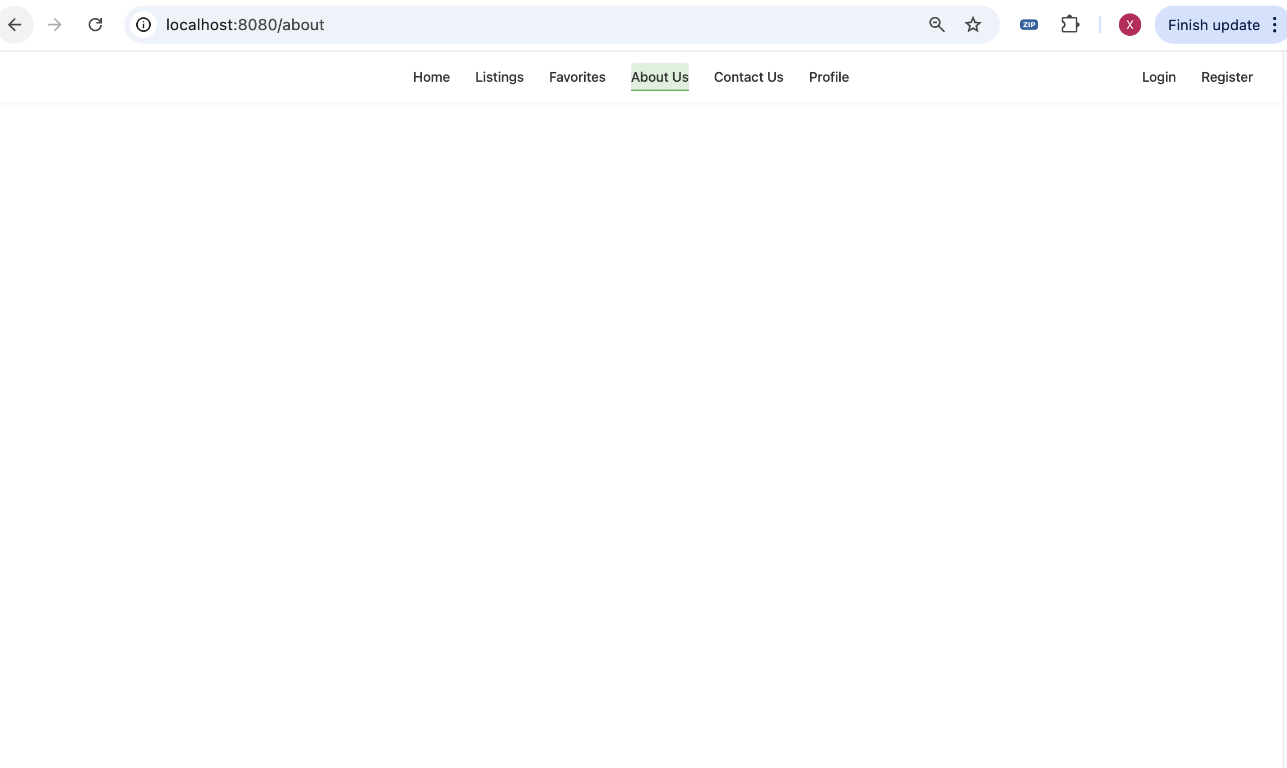

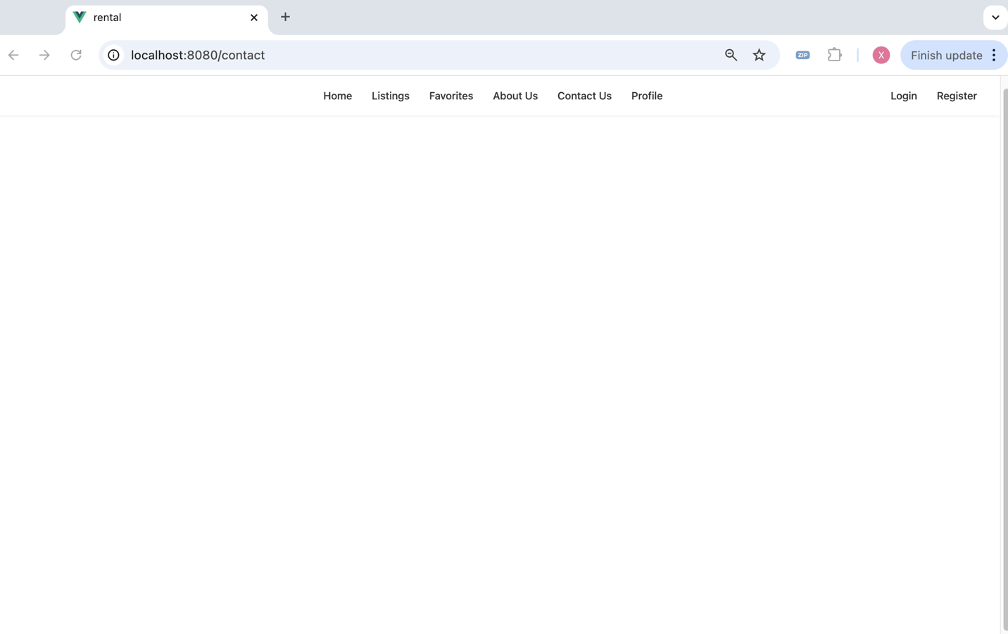
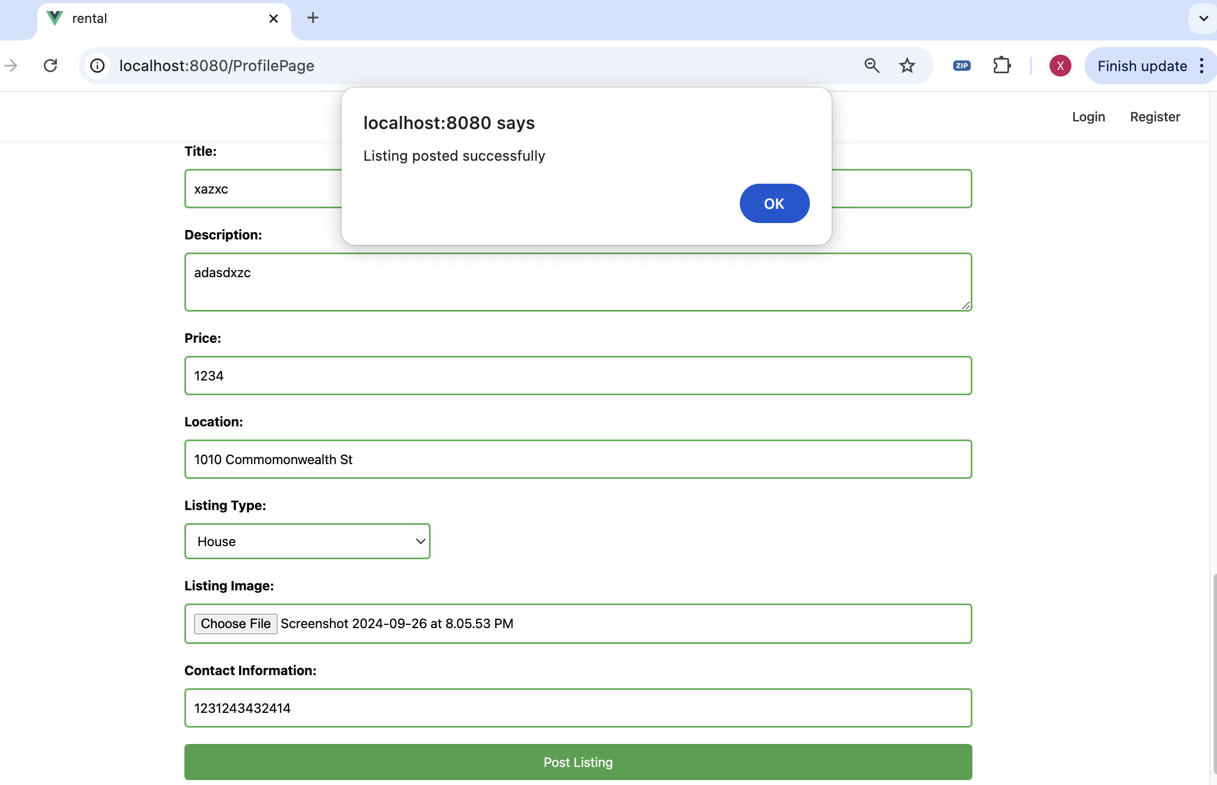

6. UI Elements Obstructed; Adjustments Needed for Font and Element Sizes:
Issue: Some UI elements are obstructed or overlap. Recommendation: Adjust the dimensions of fonts and UI elements to ensure a clear, unobstructed user interface.
